**Level 1: PC Tower Case**

**Outline**

Learn about the internals of a standard PC case by examining physical samples and selecting and labeling images found on-line. Gain deeper knowledge by researching and reporting on specific components.

**Questions**

1. Find one (or more) images that clearly show the internals of a PC Tower Case.   
   (i.e. Google images using keywords “PC Case Internals”)
2. Clearly label the following components (using arrows) on your image of the PC case internals:
   1. Motherboard

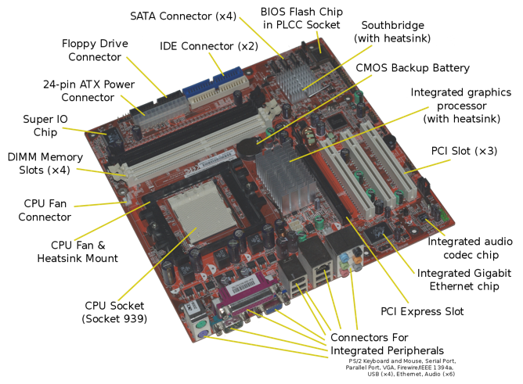

* 1. Power Supply

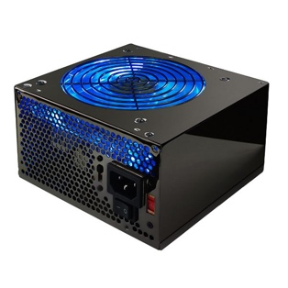

* 1. Hard Disk Drive

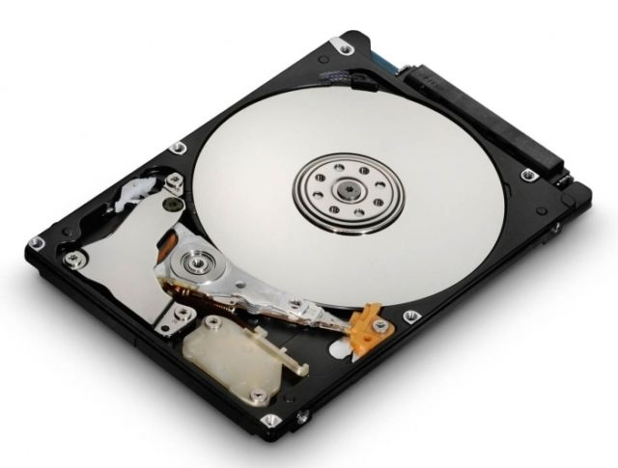

* 1. Optical Disk Drive (e.g.DVD)

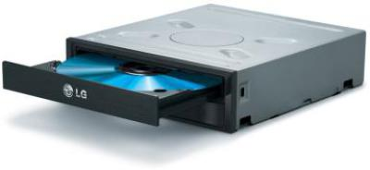

* 1. USB Expansion Ports
  2. Monitor Port
  3. Audio Ports
  4. Ethernet Port

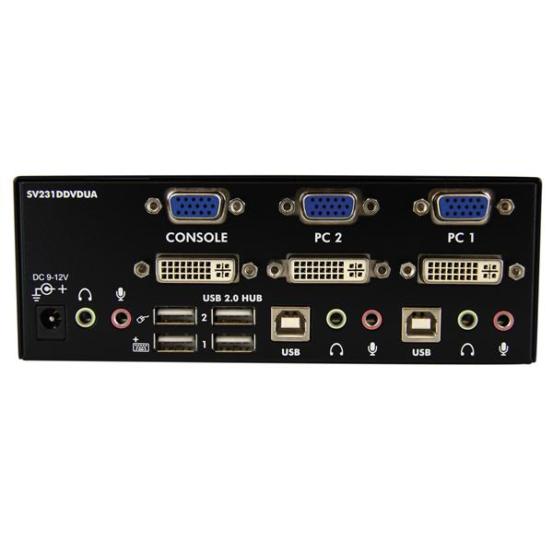

Cooling Fan  
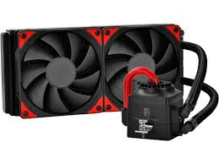

1. Research more in-depth about “Motherboards”. Make notes on the following:
   1. What different versions are currently available (speed and capacity)

Although motherboards have grown in the past few years they come in different sizes. In today’s day the most popular mother board is part of the ATX series. There are also others but this is what most people use.

* 1. How the component has changed since the 1980’s  
     The size heavily increased as one motherboard was almost the size of a room at one point. Now it is a lot smaller and is a lot more powerful. Motherboards now are a lot more useful now when compared to when computers were just being made.

1. Research more in-depth about “Hard Disk Drives”. Make notes on the following:
   1. What different versions are currently available (speed and capacity)

* IBM 350 RAMAC the capacity is 5mb
* Interface of SATA Drive
  1. How the component has changed since the 1980’s  
     A disk named the IBM 350 was developed under the code name of RAMAC. The date of announcement was in 1956. The product has changed a lot since know it is also a lot smaller as well as contains a lot more speed and memory (RAM). It is what keeps the computers memory. Also, a fun fact a hard disc drive cannot fully be erased unless destroyed as there are programs out there to retrieve “deleted information”.

**Level 2: PC Motherboard**

**Outline**

Learn about the structure of a standard PC motherboard by examining physical samples and selecting and labeling images found on-line. Gain deeper knowledge by researching and reporting on specific components.

**Questions**

1. Find one (or more) images that clearly show the layout of a PC Motherboard.   
   (i.e. Google images using keywords “PC Motherboard”)
2. Clearly label the following components (using arrows) on your image of the PC motherboard:
   1. CPU (and fan)

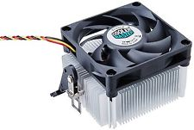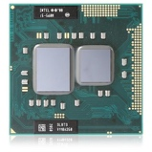

* 1. RAM Memory

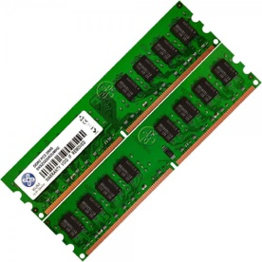

* 1. Disk Drive Interface (IDE or SATA)

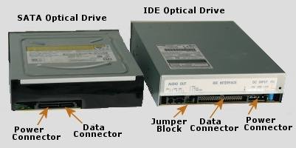

* 1. GPU Graphics Processor (either on-board or Graphics Card)

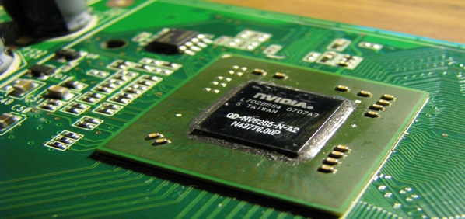

* 1. Sound Processor (either on-board or Sound Card)

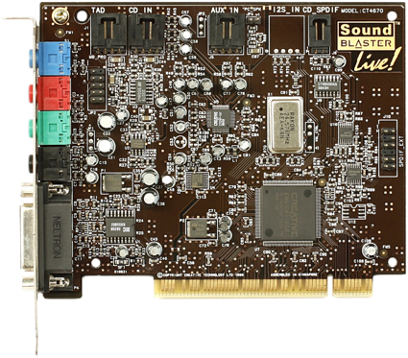

* 1. Wi-Fi / Ethernet Network Interface (either on-board or Graphics Card)

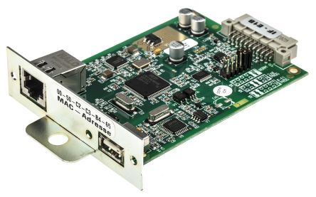

1. Research more in-depth about “CPU Processor Chip”. Make notes on the following:
   1. What different versions are currently available (speed and capacity)  
      AMD CPU AD740KYBJABOX APU A6 X2 7400K FM2+ 1MB 3900MHz BOX 65W Black

[Intel Xeon E5630 CPU Central Processing Unit Quad-core / 2.53GHz / Soc](https://www.google.ca/aclk?sa=l&ai=DChcSEwjp-a6ijYfeAhUNW4YKHehzB58YABAKGgJ2dQ&sig=AOD64_0DiojxCxOO4Fdy1n4o35LlXIJKEA&ctype=5&q=&ved=0ahUKEwjwkauijYfeAhWM1lkKHSa_C8EQ2CkI0gI&adurl=)

* 1. How the component has changed since the 1980’s  
     In 1971 the world’s first microprocessor chip was introduced, it was known as the Intel 4004. The size changed as well as the power. This is because it is one of the main things of the computer without this it can’t run. Back than they were huge now, they are very small.

1. Research more in-depth about “RAM Memory”. Make notes on the following:
   1. What different versions are currently available (speed and capacity)

MSI B350 Gaming Plus AM4 ATX Motherboard, CPU Socket AMD, Chipset, Ryzen 7, Single, DDR4 1866 2133 2400 2666 2933 3200, 64GB, DVI HDMI USB

Ballistix Sport LT 8GB Single DDR4 2666 MT/s (PC4-21300) SR x8 SODIMM 260-Pin

* 1. How the component has changed since the 1980’s  
     RAM was very small back than the quantity was not enough. It was less than a gig they didn’t even know how much that was. Now, the sizes are huge as they can come high as up to as 8GB and speeds increasing up to 1700 Mhz.

**Level 3: Peripheral Devices**

**Outline**

Learn about how peripheral devices are connected to the back side of a typical PC tower case. Examine physical samples, select and labeling images found on-line and gain deeper knowledge by researching and reporting on specific components.

**Questions**

1. Find one (or more) images that clearly show the layout of the back of a typical PC tower case.   
   (i.e. Google images using keywords “Back Of PC Tower”)
2. Clearly label the following components (using arrows) on your image of the back of a typical PC tower case:
   1. Power cord and power switch

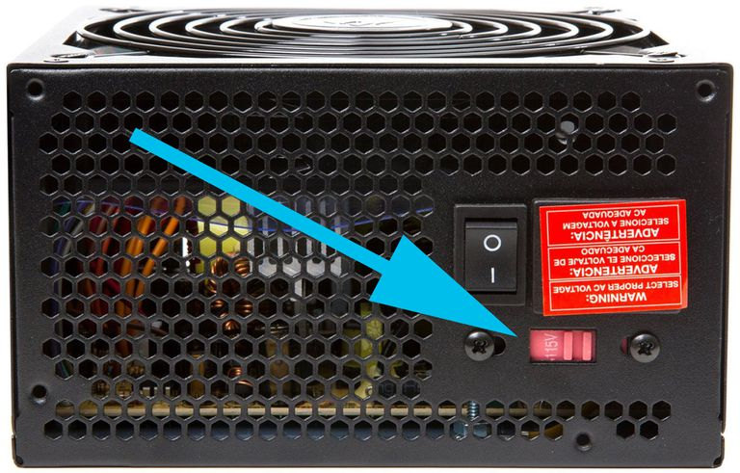

* 1. Monitor Interface (VGA or DVI or HDMI)

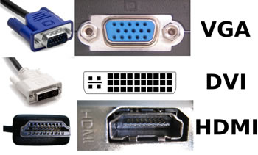

* 1. Mouse Interface (USB or PS/2)

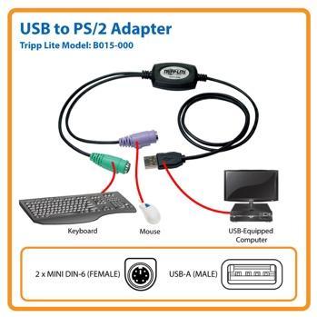

* 1. Keyboard Interface (USB or PS/2)

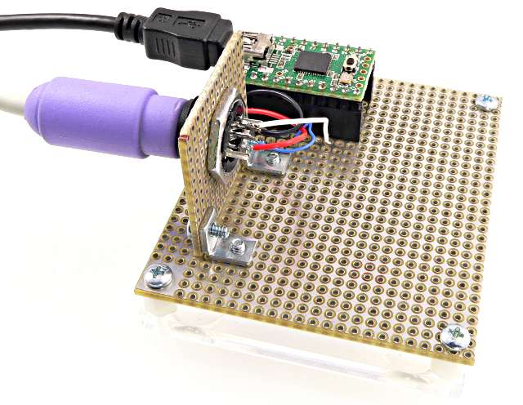

* 1. USB Ports

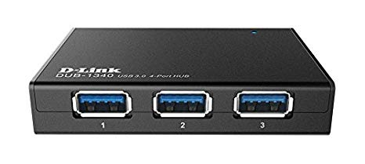

* 1. Audio Inputs / Outputs

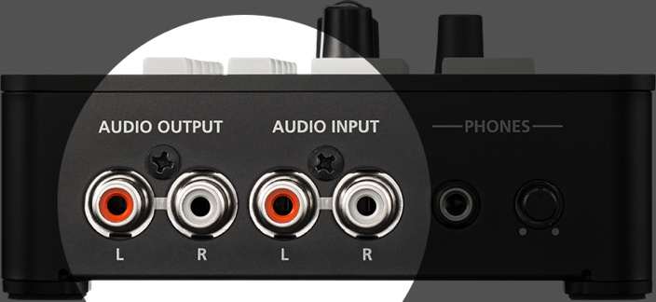

* 1. Ethernet Interface

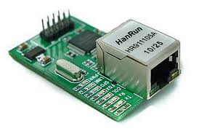

1. Research more in-depth about “Monitor Technology”. Make notes on the following:
   1. What different versions are currently available (e.g. VGA / DVI, Flat Panel Technology))

There are currently Panel technologies. This is because most computer monitors, and laptop screens consist of it. VGA is also another one as most computer monitors and anything required to display something have a switch.

* 1. How the component has changed since the 1980’s (e.g. Display Resolution, Technology)  
     Operated display devices have developed multiple systems known as electromechanical systems. This added a lot of stuff and now colors display and graphics in general are a lot better.

1. Research more in-depth about “External Portable Storage”. Make notes on the following:
   1. Floppy Disks

* Composed of a disk thin and flexible magnetic storage.
* Sealed in a rectangular plastic lined fabric.
* Read and written by FDD
* There are not used as much as there are other replacements.
  1. CD-ROM / DVD / Recordable CD/DVD
* DVD is known as digital video disc
* Developed in 1955
* Can store any digital data
* Used for movies and songs
* Disregarded now as most CPU’s have built in DVD’s and they are old
  1. USB Memory Drives
* Is a storage device that includes flash memory with an integrated USB interface
* Removeable and rewriteable
* First appeared in the early 2000s
* It is used today to contain data such as school work, videos, movies, pictures, and many more
* Useful and can contain up 512GB of information also 1TB in the expensive ones
* Very useful for on the go information and are widely used today
  1. Compact Flash Memory
* Known as a flash memory mass storage device
* Mainly used in portable electronic devices
* Memory card which contains all types of electronic information
  1. Cloud Based Storage  
     New type of storage

Contains all types of electronical information online (Cloud Based)

An example would be Google drive

Easy to access and organize and in most cases you can have up to unlimited space